How to program the 3D16MiniCube:

First wire the board so that the Nuc board can see the chip.
Power and UART:
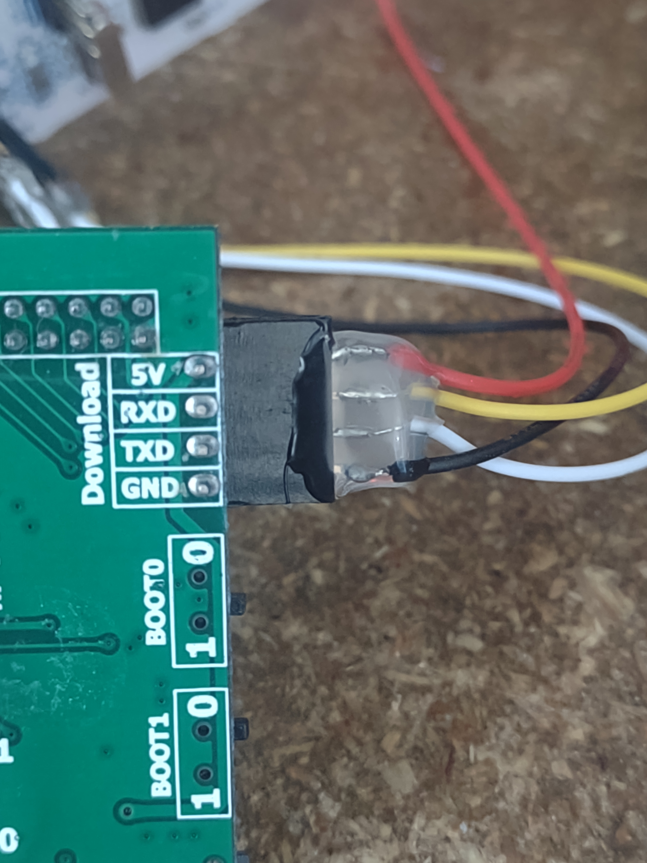
Data and Clock: - wire directly to the chip's pins (no exposed pins on the board)
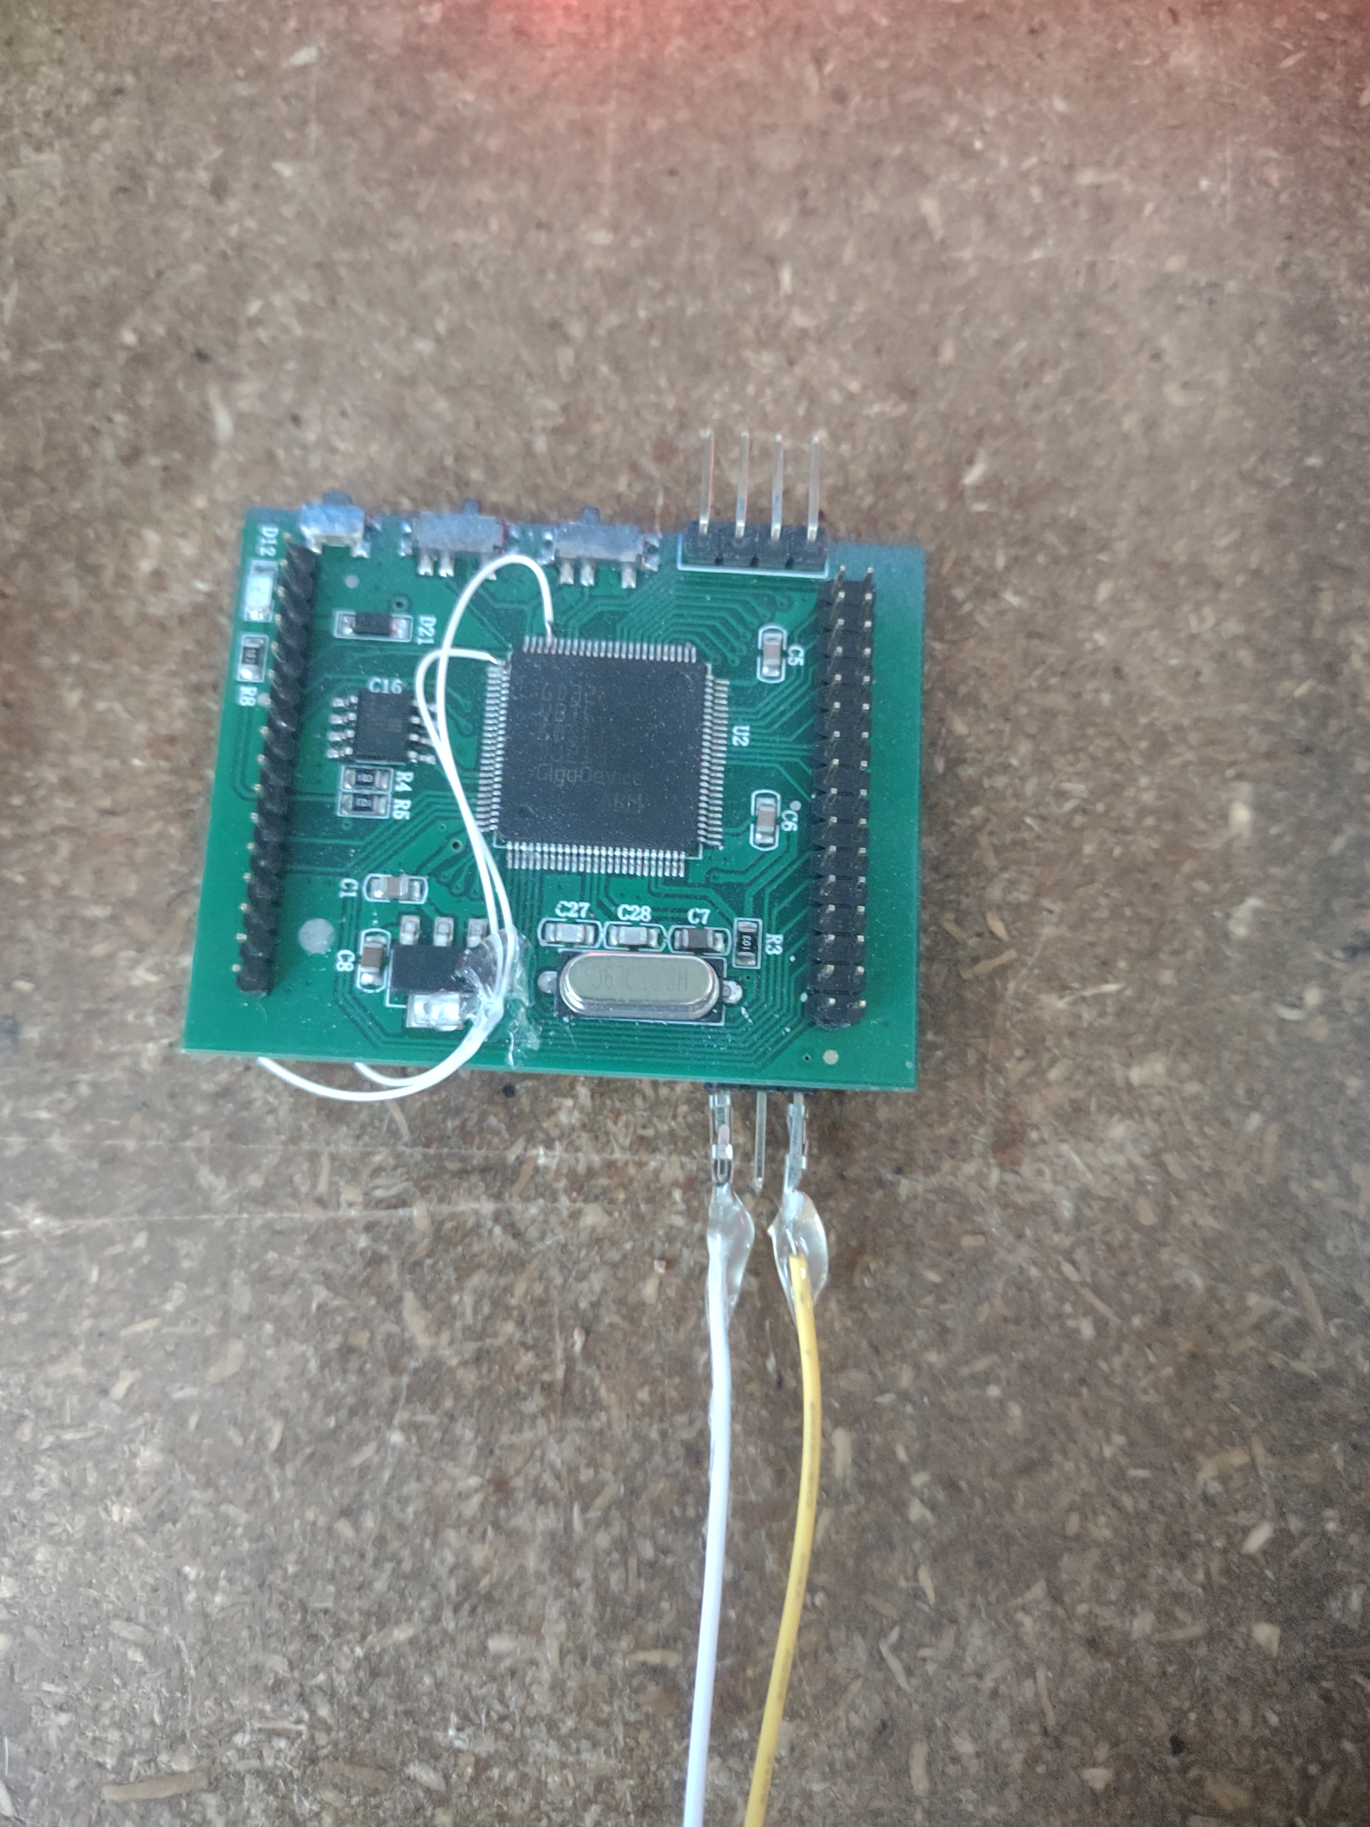
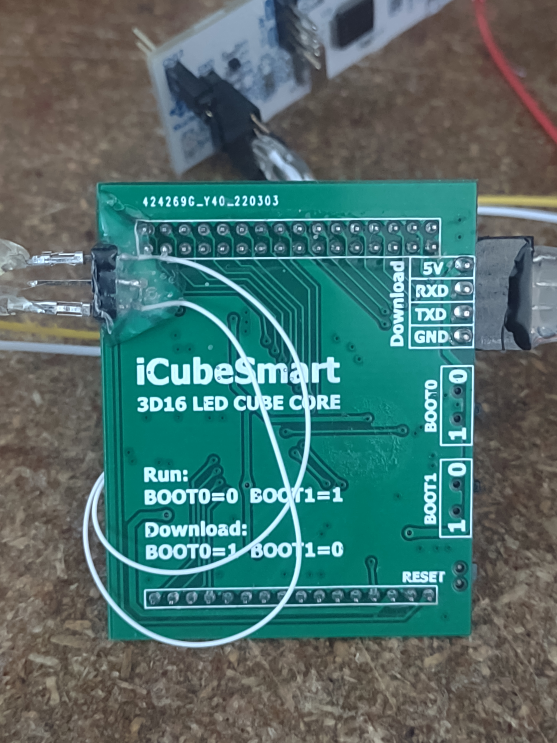
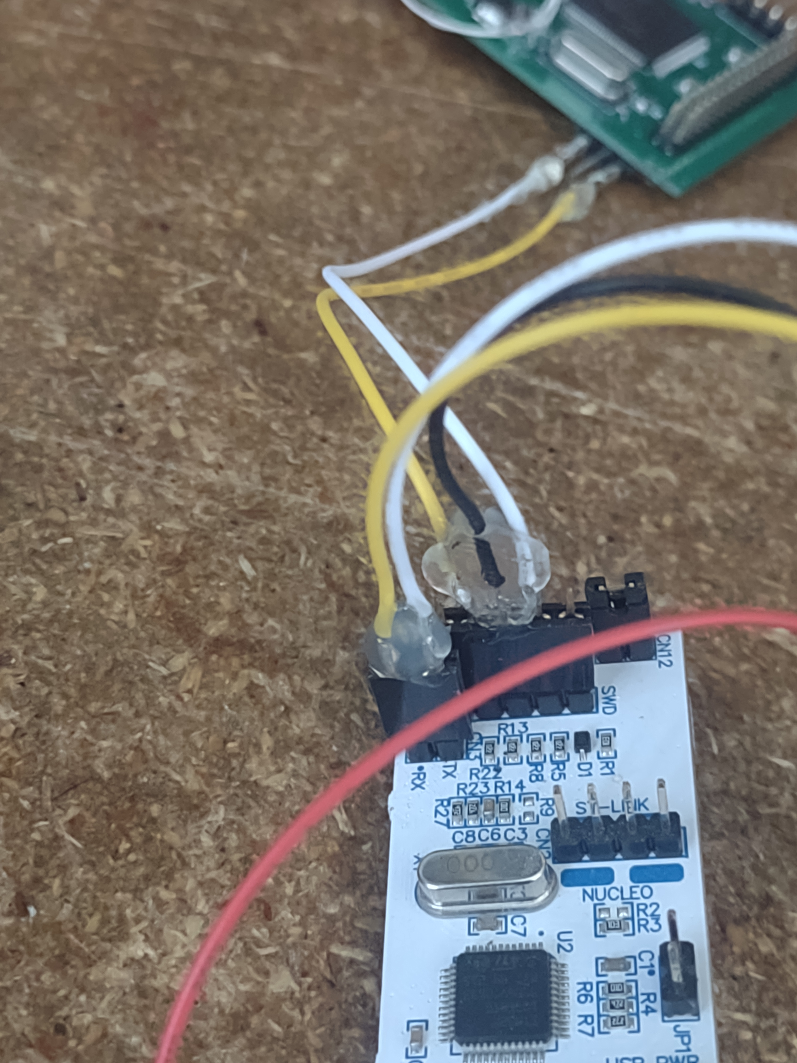
STM32 Programmer:
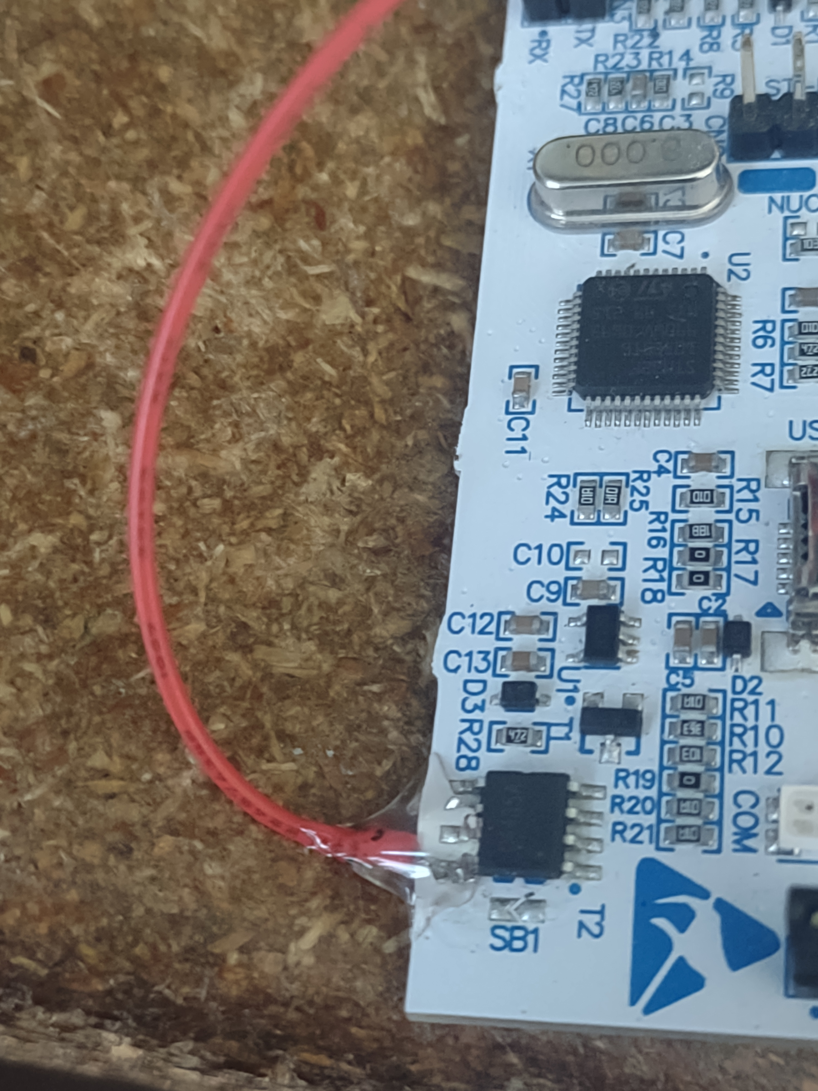
Power pin:

1) Connect the STM32 Programming board.
2) Make sure the cube board has the two onboard switches to boot0 =1, boot1 = 0:
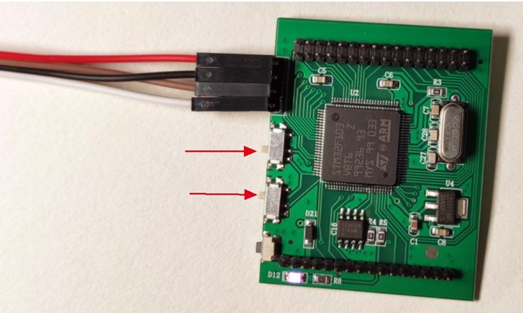
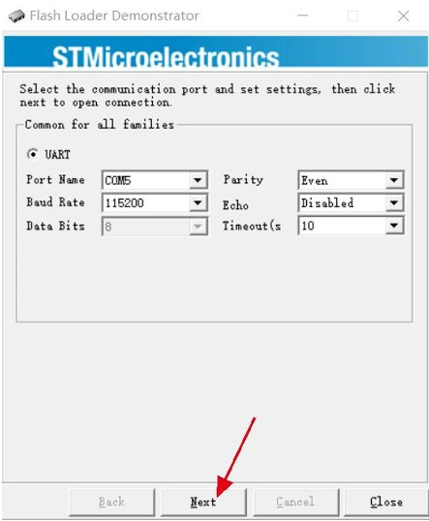
3) Open the Flash Loader Demo software

it should find the board when clicking next.

4) Open the STM32 IDE

5) Find the iCubeSmarter program: C:\Users\djy41\STM32CubeIDE\workspace_1.12.0\iCubeSmarter
6) Set the build to create a .hex file but Click Project → properties, then click C/C++ Build, and click Settings. Then click MCU/MPU Post build ouputs, and check Convert to Intel Hex file (-O ihex) . Apply, rebuild index if promoted then apply and close.

7) Build the program. Project → Build all

8) In STM32 Flash loader, locate the .hex file in C:\Users\djy41\STM32CubeIDE\workspace_1.12.0\iCubeSmarter\Debug. Flash the device.

9) Reset the board switches to boot0=0 and boot1=1. Then click the rest button and the program should run.

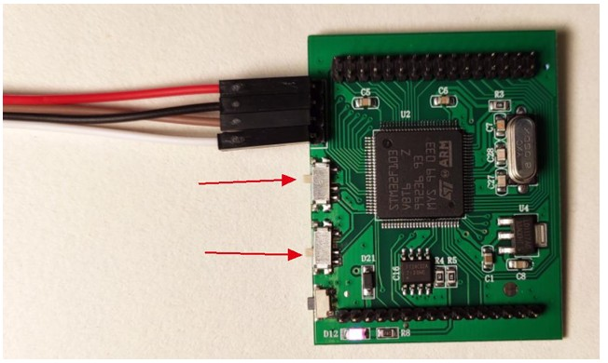

10) To reprogram the board, you might need to unplug the USB, move the switches back to the programming positions and plug the USB back in.

